ReadMe Project 2
CS-340
Kaitlyn OConnell
2026-06-19

About the Project/Project Title
Grazioso Salvare is an organization that trains rescue animals for search-and-rescue operations. They need a way to review animal shelter records and identify animals that meet specific training criteria. This project provides a MongoDB-backed dashboard that allows users to filter, review, and visualize animal shelter data through an interactive web application.
The dashboard uses CRUD functionality to retrieve data from MongoDB and display it in a format that is easy for users to understand. Users can quickly identify animals that qualify for Water Rescue, Mountain or Wilderness Rescue, or Disaster and Individual Tracking programs. The dashboard also provides visualizations and location data to help support decision making.
The main focus of this project was creating a client-server application that connects a MongoDB database to a Python dashboard using CRUD operations and interactive dashboard components.

Motivation
The motivation for this project was to gain experience building a database-driven application that allows users to interact with data through a graphical interface rather than directly through the database.
Working with MongoDB and Python provided experience developing a client/server application while implementing database concepts such as querying, filtering, and data visualization. The project also provided experience using dashboard frameworks to present information in a way that is more useful to end users.
The goal was to create a dashboard that allows Grazioso Salvare to efficiently identify animals that meet specific rescue training requirements while reducing the amount of manual searching required.

Getting Started
A CRUD Python module was created to provide access to the animal shelter database. The module includes methods that allow records to be created, read, updated, and deleted. The dashboard then uses the read functionality to retrieve records based on the selected rescue type.
The dashboard was developed using Dash and Jupyter Notebook. Interactive filtering options were added so users can switch between rescue categories. The data table, breed distribution chart, and geolocation map automatically update when a filter is selected.
After development was completed, each dashboard component was tested individually to ensure that data filtering and visualization behaved as expected.

Installation
Python – language used to writ and run the CRUD module.
MongoDB – DB used to store animal records. It can store flat files(documents) making it easy to work with python dictionaries. This makes it easier for the dashboard to reflect the data. It also gives flexible query functionality for filtering requirements.
Pymongo – library to connect python to MongoDB
Bson.objectid – used to handle mongodb documents
Base64 – encode image for display
Dash – shows the overall view of of the application components. This includes maps, charts, tables, buttons, etc.

Usage
The dashboard provides a simple user-friendly quick access to data via simplified fields and components.
Interactive filters: review filter by category(Water, Mountain, etc). This happens by executing the query via the CRUD module and returning matching records.
Interactive data: the display shows the results of the query by sorting, filtering, row selection, and pagination.
Distribution chart: the chart displays the breed records from the data table
Map: the map displays the animals location information.

Tests
- Verifying MongoDB authentication
- Confirming database connectivity
- Testing CRUD read operations
- Verifying filter functionality
- Testing data table updates
- Testing chart updates
- Testing map updates
- Verifying reset functionality
- Confirming dashboard startup without errors

Screenshots
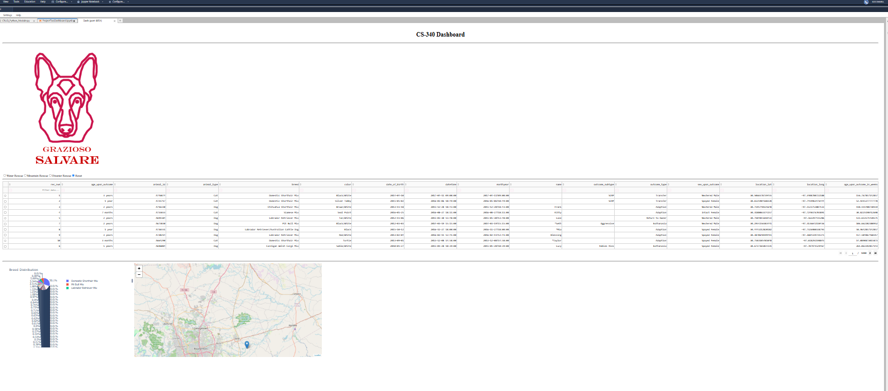
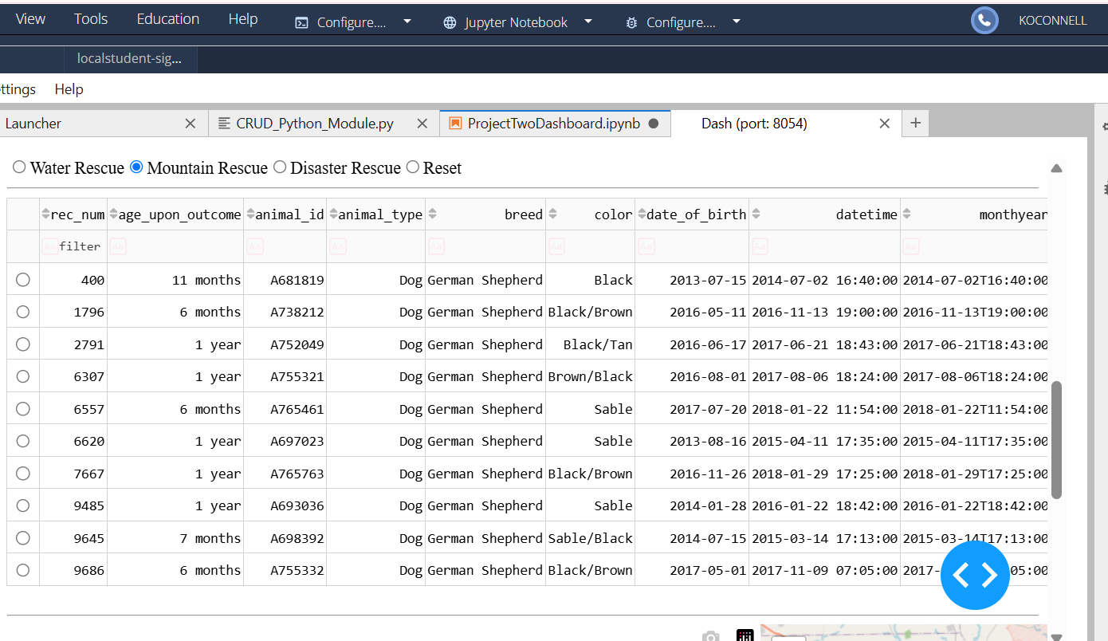
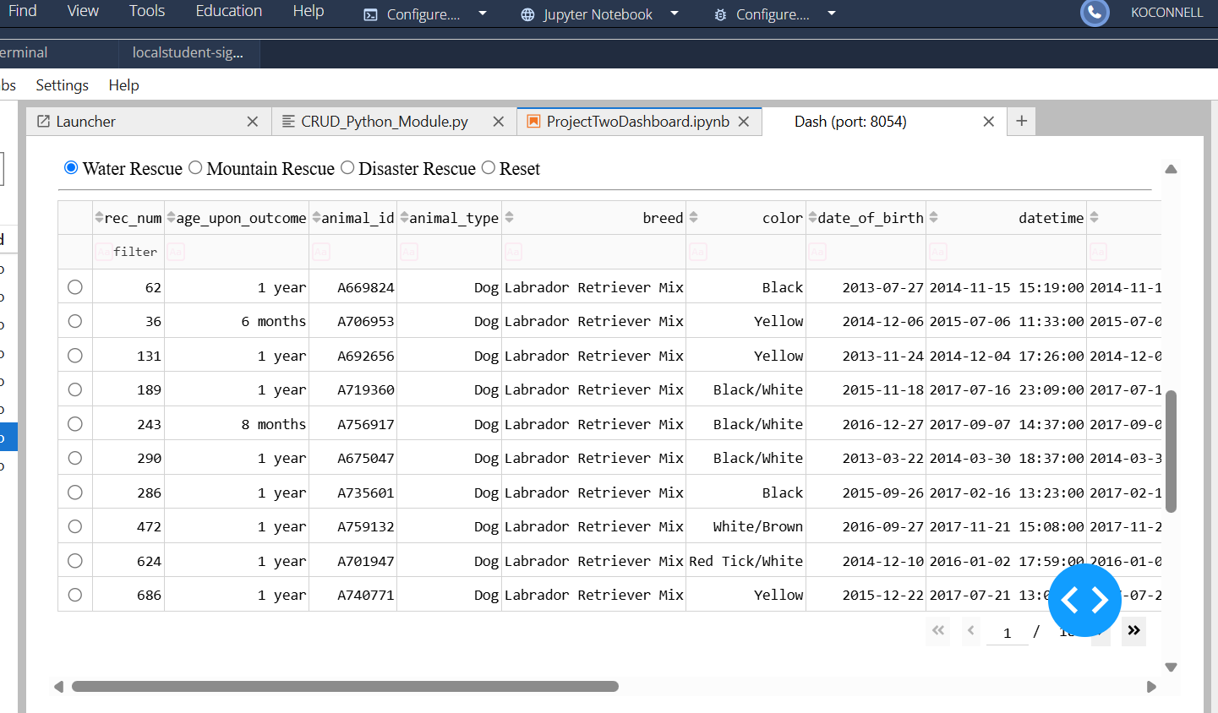
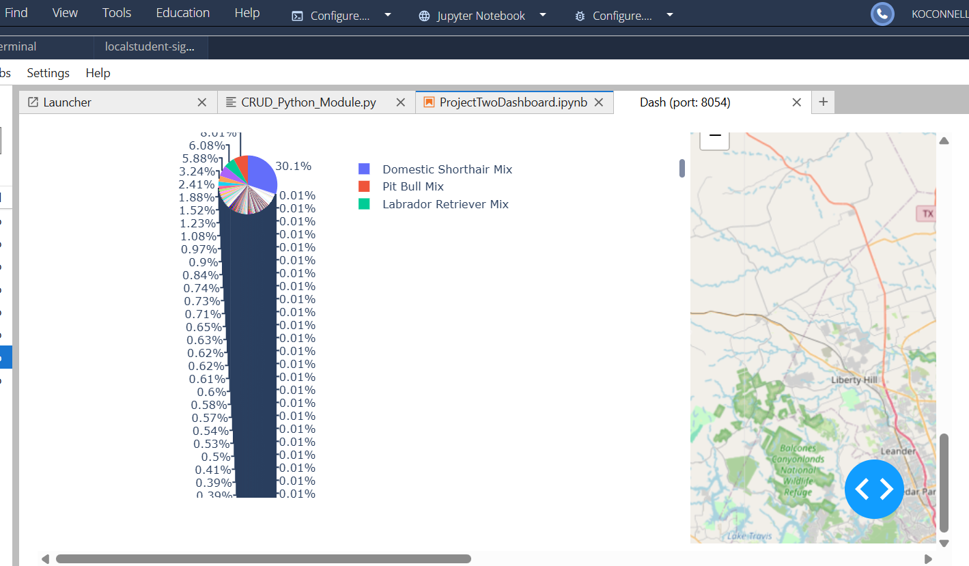
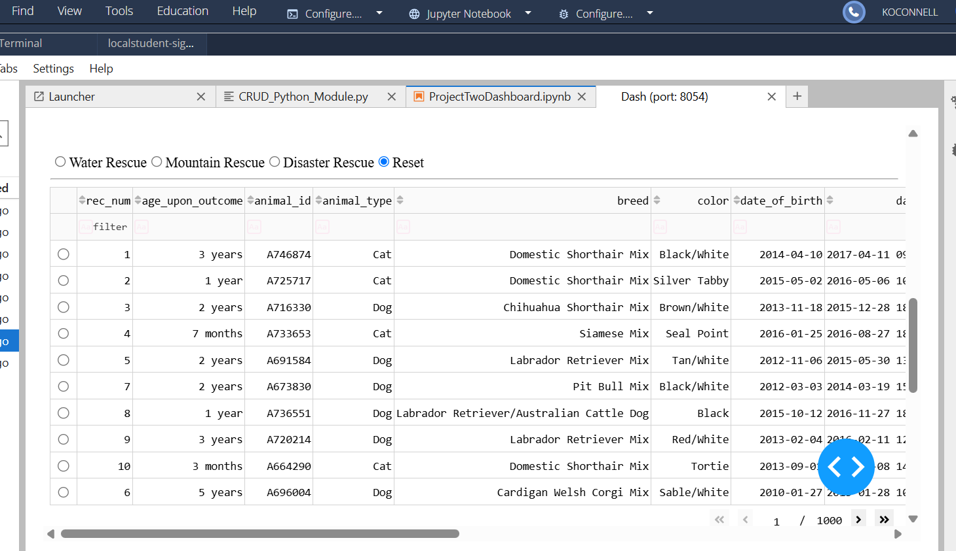

Challenges
One challenge encountered during development was creating the breed distribution pie chart. Because the Austin Animal Center dataset contains a large number of unique breeds, the chart became difficult to read when displaying all records. Many breeds only appeared once or twice in the dataset, which caused the pie chart to display a large number of very small slices and labels. As a result, the visualization appeared cluttered and did not always provide meaningful insight when the dashboard was in its unfiltered state.
Building the dashboard callbacks required additional testing to ensure that all dashboard components updated together. The radio button filters, data table, pie chart, and geolocation map all depend on the same data source. Each callback was tested individually and then as part of the complete dashboard to ensure the correct records were displayed after each filter selection.
These challenges were overcome through incremental testing, debugging, and validation of each dashboard component before integrating them into the final application.

Contact
Your Name: Kaitlyn OConnell

